Type of boundary | Movement of plates  Specify which plates move & which direction it moves | What happens during plate movement | Land forms or earth movements created & specific examples | Drawing/Illustration of plate movement
Convergent boundary (O-C) | Oceanic and continental plates move toward each other | Oceanic plate subducts under the continental plate | Trenches are formed in sea  Volcanic mountain formed on land  *Nazca plate subducting under S. American plate | 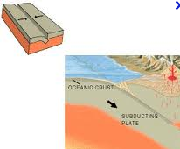
Convergent boundary (C-C) | Continental and continental plates move toward each other | Two plates collide and neither subducts | Mountains are created  *Himalayan mountains | 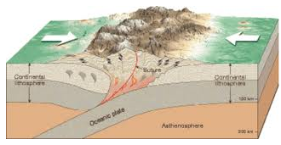
Convergent boundary (O-O) | Oceanic and oceanic plates move toward each other | The older (denser) plate subducts underneath the newer oceanic plate | Trenches  &  Underwater volcanoes island arcs  *Mariana Trench  *Hawaii/Pacific Island chains & Japan | 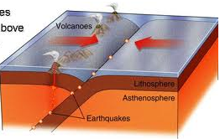
Divergent boundary | Either o-o, c-c or o-c plates move away from each other | In sea, the oceanic plates move away along the mid-ocean ridge  On land, layers of earth is torn as continents divide | mid-ocean ridge—creates new sea floors  *Mid Atlantic ridge  Rift valleys- formed as land mass is torn  *East African Rift Valley | 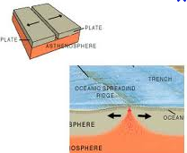
Transform boundary | Two plates of equal densities slide past one another in opposite direction | Neither plate is destroyed, no new plate (floor) is created. The energy build-up from this motion is released as an earthquake. | Earthquakes  Faults (formed when the stress causes earth’s layers to break)  *St. Andrea’s fault in CA | 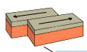
***Define Subduction & Illustrate***  ***Define Faults*** | Definition:  Definition: | The movement of older/denser plate sinking into asthenosphere under a younger/less dense plate. It is melted and recycled.  Break of earth’s layers due to stress. Happens along transform boundary. | Illustration:  Illustration:

